Set 15
Aim
To visualize and analyze monthly product sales using a grouped bar chart, stacked area chart, table, and Tableau dashboard.
Data: Product Sales Analysis
Product ID | Product Name | January Sales | February Sales | March Sales
1 | Product A | 2000 | 2200 | 2400
2 | Product B | 1500 | 1800 | 1600
3 | Product C | 1200 | 1400 | 1100

PROGRAM 1: Grouped Bar Chart of Product Sales
Create a grouped bar chart to compare the sales of each product during January, February, and March.
product <- c("Product A", "Product B", "Product C")
jan <- c(2000, 1500, 1200)
feb <- c(2200, 1800, 1400)
mar <- c(2400, 1600, 1100)

sales <- rbind(jan, feb, mar)

barplot(sales,
beside = TRUE,
names.arg = product,
col = c("skyblue", "orange", "lightgreen"),
main = "Product Sales - First Quarter",
xlab = "Products",
ylab = "Sales")

legend("topleft",
legend = c("January", "February", "March"),
fill = c("skyblue", "orange", "lightgreen"))
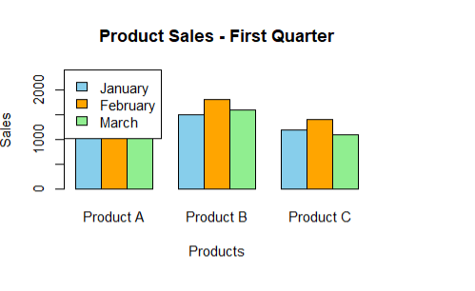

Output 1: Grouped bar chart showing January, February, and March sales for each product.
Observation
Product A has the highest sales in all three months. Product C has the lowest sales, especially in March.

PROGRAM 2: Stacked Area Chart of Overall Sales Trend
Create a stacked area chart to show the overall sales contribution of all products over the three months.
month <- c("January", "February", "March")

plot(1:3, jan, type = "o",
ylim = c(0, 7000),
xaxt = "n",
xlab = "Month",
ylab = "Sales",
main = "Stacked Area Chart of Product Sales")

axis(1, at = 1:3, labels = month)

polygon(c(1,2,3,3,2,1),
c(0,0,0,jan[3],jan[2],jan[1]),
col = "skyblue")

polygon(c(1,2,3,3,2,1),
c(jan[1],jan[2],jan[3],
jan[3]+feb[3],jan[2]+feb[2],jan[1]+feb[1]),
col = "orange")

polygon(c(1,2,3,3,2,1),
c(jan[1]+feb[1],jan[2]+feb[2],jan[3]+feb[3],
jan[3]+feb[3]+mar[3],
jan[2]+feb[2]+mar[2],
jan[1]+feb[1]+mar[1]),
col = "lightgreen")

legend("topleft",
legend = c("Product A", "Product B", "Product C"),
fill = c("skyblue", "orange", "lightgreen"))
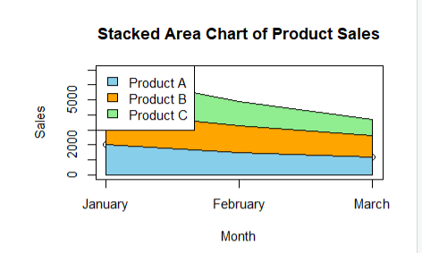
Output 2: Stacked area chart showing the sales trend and contribution of each product.
Observation
Overall sales increase from January to February and March, mainly due to the strong performance of Product A.

PROGRAM 3: Monthly Sales Table
Create a table to display the monthly sales of each product.
sales_table <- data.frame(
Product_ID = c(1, 2, 3),
Product_Name = c("Product A", "Product B", "Product C"),
January = c(2000, 1500, 1200),
February = c(2200, 1800, 1400),
March = c(2400, 1600, 1100)
)

print(sales_table)

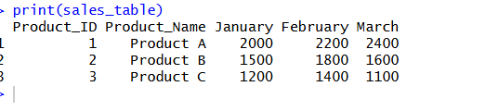
Output 3: Table displaying monthly sales for each product.
Observation
Product A shows continuous growth, Product B reaches its highest sales in February, and Product C reaches its highest sales in February before decreasing in March.

PROGRAM 4: Tableau Dashboard for Product Sales Analysis
Procedure
- Open Tableau and connect the Product Sales dataset.
- Create a Grouped Bar Chart by placing Product Name in Columns and January, February, and March Sales in Rows.
- Set the sales measures to display as side-by-side bars for comparison.
- Create a Stacked Area Chart using Month on Columns and Sales on Rows.
- Add Product Name to the chart to show the contribution of each product.
- Create a Table containing Product ID, Product Name, January Sales, February Sales, and March Sales.
- Create a new Dashboard.
- Add the grouped bar chart, stacked area chart, and sales table to the dashboard.
- Add filters or interactive options for Product Name and Month.
- Give the dashboard the title “Product Sales Analysis Dashboard”.
- Save the Tableau dashboard.
Output 4
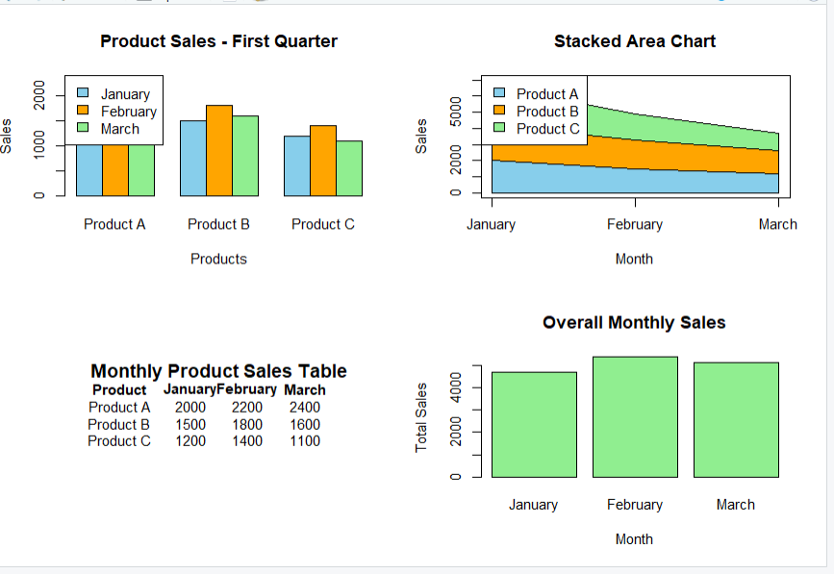
Tableau dashboard showing grouped product sales, overall sales trends, and monthly sales details.
Observation
The dashboard provides an interactive view of product sales and makes it easy to compare products and identify monthly sales trends.

Set 15 Procedure
- Create the monthly product sales dataset.
- Use R to create a grouped bar chart for first-quarter sales.
- Create a stacked area chart to show the overall sales trend.
- Create a table displaying monthly sales for each product.
- Import the dataset into Tableau.
- Create a grouped bar chart and stacked area chart in Tableau.
- Create a table containing the monthly sales data.
- Combine all three visualizations into a dashboard.
- Add filters and save the dashboard.
Set 15 Result
Product sales data was successfully visualized using a grouped bar chart, stacked area chart, and table. A Tableau dashboard was developed to compare products and analyze monthly sales trends.

